EXPT NO:7 | IMPLEMENT ADVANCED CHART TYPES USING TABLEAU AND  POWER BI
DATE: 14.08.2026

PRE-LAB QUESTIONS (PROVIDE BRIEF ANSWERS TO THE FOLLOWING QUESTIONS) :

- What is data integration in the context of Business Intelligence (BI)?

Data integration is the process of combining data from different sources into one system.It helps create a unified and consistent view of information.In BI, it is used to prepare data for analysis and reporting.Examples include integrating Excel, databases, APIs, and cloud data.

- Explain the difference between a join and a data blend in Tableau.

A Join combines tables using a common field within the data source.A Data Blend combines data from different data sources.Joins are performed at the row level before analysis.
Blending occurs during analysis using a primary and secondary data source.

- What are relationships and cardinality (e.g., one-to-many, many-to-many) in Power BI's data model?
Relationships define how tables are connected using common columns.Cardinality describes how records relate between the tables.Examples include one-to-many, one-to-one, and many-to-many.They help Power BI correctly filter and analyze related data.

- Why is data quality (e.g., consistent naming conventions, data types) crucial when integrating data from different sources?

Consistent names and data types ensure that data combines correctly.Poor-quality data can cause errors, duplicates, and incorrect results.Standardized data improves accuracy and reliability of reports.It also makes analysis and decision-making more effective.

- Name two common challenges encountered during data integration.

Two common challenges are inconsistent data formats and missing or duplicate data.Different sources may use different column names and data types.Large amounts of data can also make integration slow.These issues can lead to inaccurate analysis and reporting.

IN-LAB EXERCISE:
OBJECTIVE:
To connect, combine, and model data from multiple sources in Tableau and Power BI and create a unified, comprehensive dashboard for holistic analysis.

PROCEDURE:
- Data Collection:
  - Import two datasets:
    - Dataset 1: Sales Data (CSV) → Order ID, Order Date, Region, Sales Amount
    - Dataset 2: Regional Sales Targets (Excel) → Region, Sales Target, Target Year
- Data Preparation and Transformation:
  - Clean datasets (e.g., standardize "N. America" → "North America"). • Ensure correct data types (numeric for Sales, date for Order Date).
  - Handle missing values appropriately.
- Data Integration and Modeling:
  - Tableau: Create a join/relationship on the Region field in the Data Source pane.
  - Power BI: Use the Model view to create a relationship on Region; define cardinality (e.g., many-to-one).
- Create Calculated Fields for Comparison:
  - Target Achievement % = (SUM(Sales) / SUM(Sales Target)) * 100
  - Sales vs. Target Variance = SUM(Sales) - SUM(Sales Target)
- Design a Comprehensive Dashboard:
  - Combine visuals from both sources.
  - Add KPI cards: Total Sales, Overall Target Achievement %.
  - Use gauge/bullet charts for region-wise target performance.
  - Combined bar chart: Actual Sales vs. Target by Region.
  - Map visualization: Sales vs. Target Variance by region.
- Validate Data Integrity:
  - Cross-check joined data for accuracy.
  - Ensure dashboard filters correctly update visuals.
- Publishing and Sharing:
  - Tableau: Publish to Tableau Public or Server.
  - Power BI: Publish to Power BI Service and share.
Experiment Datasets:
  - Dataset 1: Retail Sales Data (CSV) → Order ID, Order Date, Region, Sales
  - Dataset 2: Regional Sales Targets (Excel) → Region, Sales Target, Target Year
Power BI dashboard:
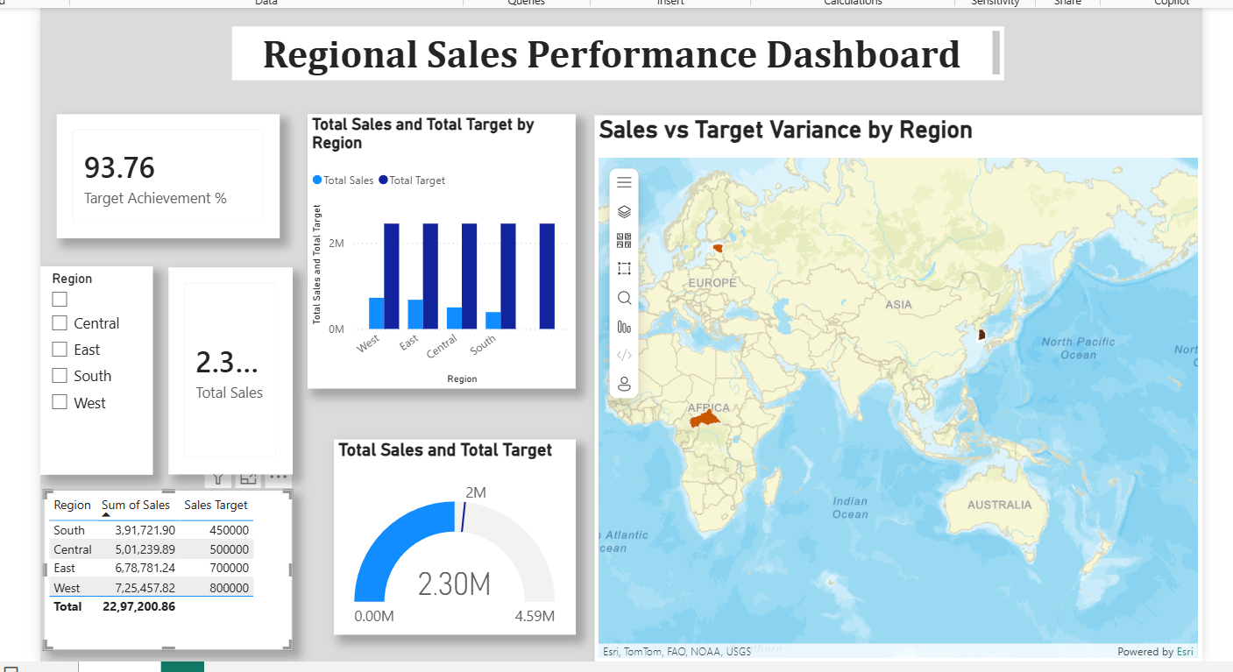
Tableau Dashboard:
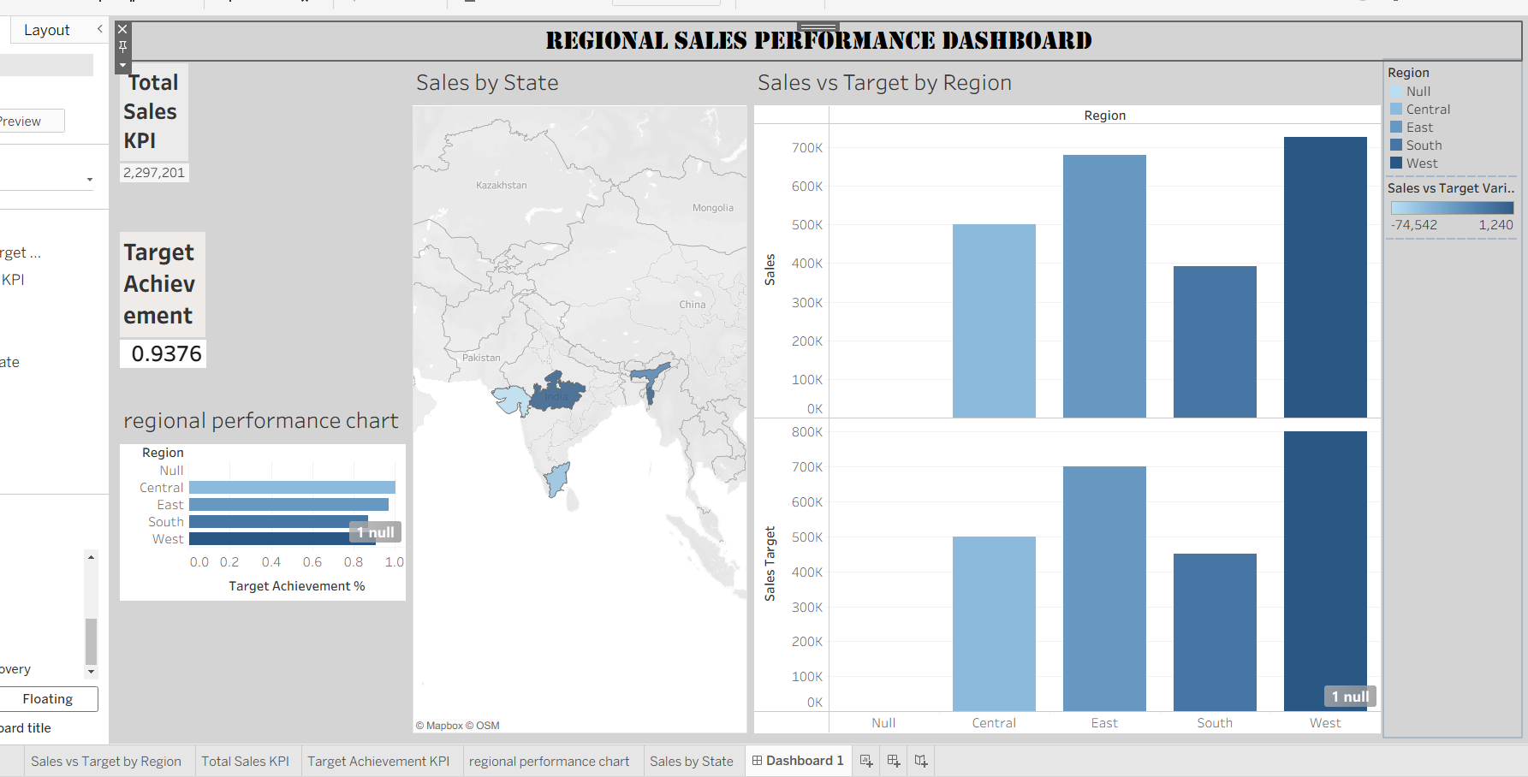
POST-LAB QUESTIONS (PROVIDE BRIEF ANSWERS TO THE FOLLOWING QUESTIONS) :

- How did integrating the sales targets data provide a more complete analytical picture than using the sales data alone?

Integrating sales targets allowed actual sales to be compared with planned targets.
It showed whether each region or product was meeting its expected performance.
This provided more useful insights than looking at sales figures alone.
Managers could identify both high-performing and underperforming areas.

- Describe the type of join or relationship you used to combine the two datasets and explain why it was the appropriate choice.

A relationship/join based on the Region field was used to connect the two datasets.
Each sales record was matched with the corresponding regional target.
This was appropriate because both datasets contained a common Region field.
It allowed sales and targets to be analyzed together.

- What challenges, if any, did you face regarding data granularity or mismatched keys (e.g., different region names) between the two sources?
Some region names may have had differences in spelling or formatting between the sources.
The datasets could also have different levels of detail, such as individual sales versus regional targets.
These differences can prevent records from matching correctly.
Standardizing the region names and data structure helped resolve the issue.

- How can creating variance calculations (e.g., Sales vs. Target) help a business manager make better decisions?
Variance calculations show the difference between actual sales and the target.
A positive variance indicates that sales exceeded the target, while a negative variance shows a shortfall.
Managers can quickly identify areas that need improvement.
This supports better planning, resource allocation, and decision-making.

- What other data source (e.g., marketing campaign data, customer demographics) could you integrate to further enrich this analysis, and what new insights might it provide?
Marketing campaign data could be integrated with the sales data.It could show whether campaigns increased sales in specific regions or periods.Managers could identify which campaigns generated the best results.This would help improve future marketing strategies and budget allocation.
RESULT:

The retail sales and regional targets datasets were successfully connected, cleaned, and integrated in Tableau and Power BI. Relationships between the sources created a unified data model. The dashboard visualized sales performance against targets, enabling variance analysis and providing insights into regional performance not possible with a single data source.

ASSESSMENT

Description |  | Max Marks | Marks Awarded
Pre Lab Exercise |  | 5
In Lab Exercise |  | 10
Post Lab Exercise |  | 5
Viva |  | 10
 | Total | 30
 | Faculty Signature

